August 8th, 2010
Hi
The language issue over Cantonese has not gone away. Last weekend there were protests in HK and Guangzhou over the perceived loss and downgrading of Cantonese culture.
There has been a change is duty-free regulations in HK. People can now only bring in 19 cigarettes (i.e. one short of a packet) into HK duty free. If they buy them outside of HK, they can just remove one and throw it away. But if they buy them at a duty-free shop in HK just before going through customs (which can be done at the border railway stations), they cannot do this. Instead. they must fill out a declaration form and then a shop assistant must take the person to customs, which can take about 30 minutes!
On Wednesday, I went to Tuen Mun hospital to have the stitches removed from the nose biopsy. The results showed that most of the sBCC was excised during the biopsy. As there is only a little bit left, no plastic surgery will be needed. We will just keep the remainder under observation. There are certainly differences between the hospital system and the health clinic systems. I prefer to have a biopsy at the clinic as it wastes less time. At the hospital it involves at least half a day and often more, and is more expensive as you have to pay for admission. However, the biopsy results come much quicker at the hospital – this latest took only about three working days as against up to six weeks at the clinics.
In HK, there has been quite an uproar (another one!) against the sentence handed down to the niece of a High Court judge for drunken driving, causing an accident, refusal to take a breathalyser test and for an assault on a policemen (for third time!). All she got was a 12-month probation, a small fine and the suspension of her license for a year whereas other 'less well connected' offenders have been given custodial (jail) sentences even for a first offence. In passing judgement, the magistrate (very unfortunately) referred to her 'good education' and 'well-off family'. That did not go over well. The government asked the magistrate to review the light sentence which he did but did not change it. The government will now send it to the court of appeal.
In China, there has been another knife attack at a kindergarten; three children were killed, with many other children as well as teachers injured. Talking about kindergartens in China, at least in major centres such as Beijing, there is now extreme pressure to get children into kindergartens. Children as young as 2 ½ years have to have a long interview, provide a CV, a portfolio of work (such as artwork) and have good references!! In addition, it can cost more than HK$130 000 pa for fees!! These are private kindergartens. Although there are some state kindergartens which are very cheap, these are reserved for the children of government workers and there are never enough places anyway.
The last HKCEE (Form 5 HK Certificate of Education Exam) results were given out the other day. They are the last, because, starting in September, secondary schools switch from a sever-year system with exams at the end of F5 and F7, to a six-year system with just one exam at the end of F6. This means that those students who did not do well and want to repeat F5 will be unable to do so as the syllabuses are all new and there will no longer be HKCEE exams. Also, many whose results were good enough for them to qualify for F6 cannot get a place as there are just not enough.
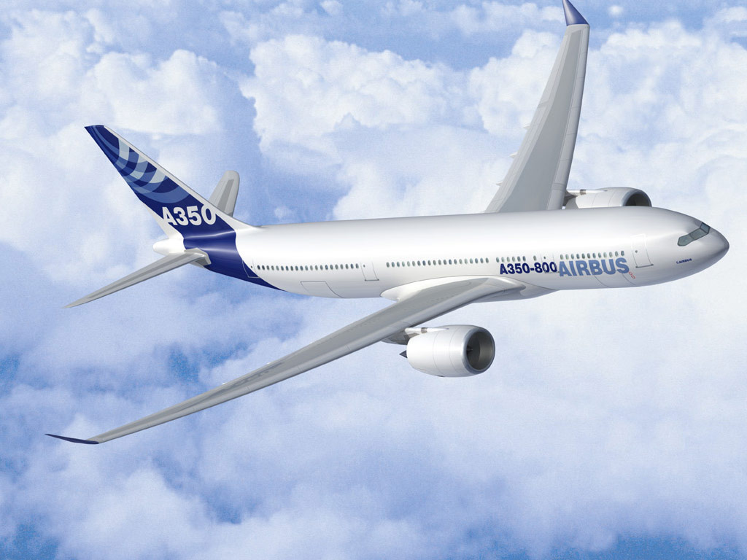
Cathay Pacific Airways announced the other day that it is to buy 36 new aircraft, 30 of which will be A350s rather than B787s and the other six will be B777s.
Friday was the anniversary of the dropping of the atomic bomb on Hiroshima. A representative from the US attended, the first time this has occurred.
Also on Friday, I went to CU early afternoon to get a witness for the photo for my passport. As I think I have mentioned, it is necessary to get a person who knows you from just a few categories, including teachers. So I went to my old Faculty of Education and managed to find a person. This was not easy as it is the holiday period and many are away, and also there are many new people I do not know. While at CU, I also had a dental hygiene appointment. On return here I went to the PO and posted the passport application.
In Christchurch yesterday, the ABs beat the Wallabys 20-10. But as they did not get a bonus point, which would have enabled them to tie up the Tri-Nations title. SA, with three losses cannot now get the title. Australia, with one win, could, mathematically, still get the title if they win their remaining three games and score a bonus point in each and the ABs lost their remaining two games and score no points. (Remember a losing team gets zero for the loss, but can get up to two bonus point – one if they score 4 or more tries and one if they are within 7 points of the winner's score.)
Cheers

